

SERVER RESPONSE TIME PREDICTION USING REGRESSION MODELS

a micro project e-report Submitted by

Dharani Dharan M (URK25AI1043)
Danush A T (URK25AI1013)
Rowan Matthew R (URK25AI1012)
Lithish Kumar P (URK25AI1027)

in partial fulfillment of the Continuous Internal Examination
of
25DC210 -PROBABILITY AND STATISTICS FOR DATA SCIENCE AND CYBER SECURITY ENGINEERS

in
B. Tech. ARTIFICIAL INTELLIGENCE AND DATA SCIENCE ENGINEERING
under the supervision of
Dr. H JUDE IMMACULATE


KARUNYA INSTITUTE OF TECHNOLOGY AND SCIENCES
(Deemed-to-be-University)
Karunya Nagar, Coimbatore - 641 114.
November 2025
BONAFIDE CERTIFICATE

This is to certify that the micro project e-report titled “Server Response Time Prediction Using Regression Models” is the bonafide work of
“Dharani Dharan M (URK25AI1043), Danush AT (URK25AI1013),
Rowan Matthew R (URK25AI1012) and Lithish Kumar P (URK25AI1027)” who carried out the project work under my supervision.

Dr.H.Jude immaculate
Assistant Professor
Division of Data Science and Cyber Security
School of Computer Science and Technology

Submitted for the micro project presentation held on 27.10.2026

ABSTRACT
Server response time is a key indicator of the quality of web and cloud services, and predicting it in advance helps providers plan capacity and detect abnormal behaviour. This micro project investigates, using probability and statistics, whether regression models can predict server response time from workload and resource parameters. A public cloud workload dataset from Kaggle containing 5,000 task records was used, with response time defined as the sum of task waiting time and task execution time.
After cleaning and exploratory statistical analysis (descriptive statistics, skewness and Pearson correlation), simple and multiple linear regression models were fitted by the least squares method in Python, and a random forest was trained for comparison. The models were evaluated with R², MAE, RMSE and 5-fold cross-validation, and hypothesis tests (t-tests and an F-test) and 95% confidence intervals were used to judge which parameters significantly influence response time.
Two scenarios were studied. With workload and resource parameters alone (CPU utilisation, memory consumption, active users, bandwidth and similar columns), the model explained almost none of the variation in response time (R² = 0.002, F-test p = 0.57), so these parameters had no statistically significant joint effect in this dataset. When the predicted execution duration was added, R² rose to 0.944 and that duration was the only significant predictor. A second dataset of real website measurements also gave weak results (R² = 0.006).
The study demonstrates a complete regression and hypothesis-testing workflow and shows why statistical validation is essential before a prediction model is trusted for monitoring or anomaly detection.
Keywords: server response time, linear regression, least squares, correlation, hypothesis testing, cross-validation, cloud workload, Python

TABLE OF CONTENTS

S.No. | Title |  | Page No.
 | BONAFIDE CERTIFICATE |  | ii
 | ABSTRACT |  | iii
 | TABLE OF CONTENTS |  | iv
1 | INTRODUCTION |  | 1
 | 1.1 | Background of the selected problem | 1
 | 1.2 | Industry Relevance | 1
 | 1.3 | Aim and Objective of the Micro Project | 2
 | 1.4 | Link to SDG / KITS Technology Mission | 2
2 | LITERATURE REVIEW |  | 3
3 | METHODOLOGY |  | 6
4 | FABRICATION/SIMULATION/PROGRAM OR CODE/DESIGN |  | 9
5 | RESULTS AND INTERPRETATION |  | 12
6 | CONCLUSION AND FUTIRE SCOPE |  | 15
7 | DECLARATION |  | 16

1. INTRODUCTION
1.1 Background of the selected problem
Modern life depends on web applications and cloud services, from online banking and e-commerce to learning platforms and healthcare portals. For all of them, server response time, the time a server takes to answer a request, is one of the most visible measures of quality. Slow or unpredictable responses frustrate users, reduce engagement and can breach the Service Level Agreements (SLAs) that providers sign with their clients.
Response time is a random quantity. It changes from one request to the next because of varying numbers of concurrent users, CPU and memory pressure, network conditions and the type of task being run. Because it is uncertain, it is naturally studied with probability and statistics: its distribution can be described, its relationship with other measurements can be quantified through correlation and regression, and claims about those relationships can be tested with hypothesis tests.
This micro project therefore asks a practical statistical question: can server response time be predicted from workload and resource parameters using regression models, and can we prove statistically that these parameters really influence it? A public cloud workload dataset is analysed in Python to answer this.
1.2 Industry Relevance
Predicting response time is a routine requirement in web application engineering and cloud operations. Companies use such predictions for capacity planning (how many servers are needed for next month's traffic), autoscaling (adding resources before a slowdown happens), SLA monitoring and intelligent monitoring dashboards. Regression models are widely used for this purpose because they are fast to train, easy to interpret and simple to deploy inside monitoring tools.
Deviations between predicted and observed response time are also useful in cyber security. A sudden jump above the predicted value can be an early indicator of a Distributed Denial of Service (DDoS) attack, resource exhaustion or a failing component, which links this project directly to anomaly detection in data science and cyber security systems.
1.3 Aim and Objective of the Micro Project
Aim: To investigate, using probability and statistics, how well regression models can predict server response time from workload and resource parameters, and to test which parameters have a statistically significant effect.
Objectives:
• To obtain a public cloud workload dataset and define server response time from its recorded timings.
• To clean the data and describe it using measures of central tendency, variance, skewness and correlation.
• To build simple and multiple linear regression models in Python using the least squares method.
• To evaluate the models using R², MAE, RMSE and 5-fold cross-validation.
• To apply hypothesis tests (t-test for coefficients, F-test for the model) and confidence intervals to decide which parameters significantly influence response time.
• To interpret the results honestly, including cases where the model has little predictive power.
1.4 Link to SDG / KITS Technology Mission
SDG 9 (Industry, Innovation and Infrastructure): reliable and responsive digital infrastructure is a base for innovation. Predicting server performance helps providers build resilient web and cloud services that stay usable under heavy load.
SDG 13 (Climate Action), indirect link: accurate performance prediction allows servers to be sized correctly instead of over-provisioned, which reduces wasted energy in data centres.
KITS Technology Mission: the Institute carries out technology missions that apply modern tools to real-world problems. This project supports that spirit by applying statistical modelling and data science to a practical engineering problem, and the same approach can support the web-based services used in missions such as agriculture, water and healthcare, where dependable online systems are important.
2. LITERATURE REVIEW
This chapter surveys ten research papers on predicting server and web-service response time using regression and related models. Table 2.1 summarises the mathematical concept used in each work and its application, and the paragraphs that follow review each paper in turn.
Table 2.1 Summary of the reviewed papers
S.No | Authors & Year | Title | Mathematical / Regression Concept | Application
1 | B. K. Aichernig, P. Bauerstätter, E. Jöbstl, S. Kann, R. Korošec, W. Krenn, C. Mateis, R. Schlick, and R. Schumi (2019) | Learning and Statistical Model Checking of System Response Times | Multiple linear regression to derive response-time distributions, combined with statistical model checking (stochastic timed automata) | Performance testing and QoS assurance of industrial web-service systems under varying user load
2 | S. N. Nagarajan and S. Ravikumar (2012) | Model for Predicting End User Web Page Response Time | Multivariate regression combining web-page composition, network, browser-download, and browser-rendering characteristics | Predicting perceived end-user web page response time early in the design lifecycle to meet performance SLAs
3 | J. M. Tomczak, J. Świątek, and K. Latawiec (2013) | Gaussian Process Regression as a Predictive Model for Quality-of-Service in Web Service Systems | Gaussian Process Regression (non-parametric Bayesian regression) with linear, squared-exponential, and complex kernels, benchmarked against CART | Predicting average latency (response time) of a web-service execution system for resource allocation
4 | Y. Amannejad, D. Krishnamurthy, and B. H. Far (2019) | Prospective: A Data-Driven Technique to Predict Web Service Response Time Percentiles | Fully automated data-driven simulation using Collaborative Filtering to estimate response-time behaviour per transaction type and load level | Predicting SLA-relevant response-time percentiles (e.g., 95th percentile) for system sizing and capacity planning
5 | S. Muppala, X. Zhou, L. Zhang, and G. Chen (2012) | Regression-Based Resource Provisioning for Session Slowdown Guarantee in Multi-Tier Internet Servers | Offline-trained statistical multiple regression models capturing relationships between workload, resource allocation, and session slowdown, combined with online monitoring | Dynamic resource provisioning to guarantee session slowdown (a response-time-based performance metric) in multi-tier e-commerce web servers
6 | Z. Li, M. Zhang, Z. Zhu, Y. Chen, A. Greenberg, and Y.-M. Wang (2010) | WebProphet: Automating Performance Prediction for Web Services | Timing-perturbation-based dependency extraction combined with predictive modelling of page-load-time distributions | Predicting the response-time / page-load-time impact of infrastructure or object-handling changes for large-scale production web services
7 | H. Nourikhah, M. K. Akbari, and M. Kalantari (2016) | Modeling and Predicting Measured Response Time of Cloud-Based Web Services Using Long-Memory Time Series | ARIMA and long-memory ARFIMA time-series regression, validated using Hurst-exponent estimators | Forecasting future response-time / QoS values of real-world cloud services at runtime
8 | G. Sumathi and R. Raju (2012) | Software Aging Analysis of Web Server Using Neural Networks | Radial Basis Function (RBF) Feed-Forward Neural Network regression, evaluated using RMSE and MAPE | Forecasting Apache web-server response time, swap-space usage, and free memory to schedule preventive software rejuvenation
9 | D. Noetzold, A. G. de M. Rossetto, J. F. De Paz Santana, and V. R. Q. Leithardt (2026) | A Microservices-Based Endpoint Monitoring Platform with Predictive NLP Models for Real-Time Security and Hate-Speech Risk Alerting | Simple linear regression modelling response time, CPU usage, and memory usage as functions of increasing request load | Scalability evaluation within a real-time microservices monitoring and alerting platform
10 | K. Dou, B. Guo, and L. Kuang (2017) | A Time-Aware Weighted-SVM Model for Web Service QoS Prediction | Weighted Support Vector Machine (SVM) regression with time-decay weighting of historical QoS records | Personalized prediction of QoS attributes, including response time, for service recommendation

2.1 Review of the papers
1. Aichernig et al. (2019) proposed a method that learns response-time distributions from model-based testing logs using multiple linear regression, then embeds these distributions into a functional system model to build a stochastic "cost model." This cost model is checked using statistical model checking (SMC) to answer quantitative questions about expected response times under different user populations. Key findings showed that engineering combined features (such as merging request-type attributes) improved regression accuracy, and that the learned model closely matched real response-time behaviour on an industrial case study. The approach is applied to predict whether a web-service system will meet response-time thresholds before deployment, supporting proactive performance testing. Its main advantage is that it avoids expensive, repeated load testing by simulating performance from a learned regression model, saving computation time and cost. However, the technique assumes response times can be reasonably approximated by linear regression, which may not capture highly non-linear or bursty load patterns, and it requires substantial log data from model-based testing to train an accurate model.
2. Nagarajan and Ravikumar (2012) proposed a regression-based model for predicting the end-user perceived response time of a web page, built from key parameters covering page layout, network conditions, browser download behaviour, and browser rendering. Key findings showed that the model could estimate perceived responsiveness early in a page's design lifecycle, before the page is deployed, by combining these parameter groups into a single predictive equation. The model was validated experimentally on live Yahoo! web pages in two different countries and compared against a third-party measurement application, showing close agreement. The approach is applied to help web designers meet performance Service Level Agreements (SLAs) by predicting responsiveness before committing to a particular page layout. Its advantage is that it ties response-time prediction directly to controllable design parameters, giving developers actionable levers to improve performance. A limitation is that network characteristics vary widely across countries and connection types, so the model needs re-calibration for regions or conditions very different from those tested.
3. Tomczak, Świątek, and Latawiec (2013) proposed using Gaussian Process Regression (GPR) to predict Quality-of-Service attributes, specifically average response latency, of a simulated web-service execution system. A simulation environment generating realistic teletraffic was built in MATLAB, and GPR with different kernel functions was compared against Classification and Regression Trees (CART) using Mean Absolute Error and Mean Squared Error. Key findings showed that GPR with a linear kernel achieved the lowest error and performed statistically significantly better than CART (confirmed via a two-sample t-test). The model is applied to predict latency for a given input workload so that computational resources can be allocated optimally. Its main advantage is that GPR is a probabilistic model, so it returns both a predicted value and an uncertainty estimate, which is valuable for risk-aware decision-making. A limitation is that Gaussian Process Regression scales poorly with very large datasets due to its matrix-inversion cost, and the study was validated only in a simulated environment rather than a live production system.
4. Amannejad, Krishnamurthy, and Far (2019) proposed Prospective, a fully automated, data-driven technique for predicting Web service response-time percentiles, addressing the fact that Service Level Agreements typically specify targets such as the 95th percentile of response time. At its core is a lightweight simulator that, given a specification of expected future workload, uses Collaborative Filtering (CF) on historical response-time data to estimate the response-time behaviour of each transaction type under a given load, even for previously unseen load-transaction combinations. Key findings showed that Prospective predicted various response-time percentiles with high accuracy across a wide variety of workloads, outperforming techniques that require manual construction of queueing or machine-learning models. The technique is applied to system-sizing exercises and SLA-compliance checking, letting operators verify in advance whether a planned workload will violate response-time targets. Its advantage is that it removes the labour-intensive, expert-driven step of manually building analytic or simulation models, making percentile prediction fast and automated. A limitation is that prediction quality still depends on the richness of the historical data repository, since sparse coverage of certain transaction-load combinations can reduce CF accuracy.
5. Muppala, Zhou, Zhang, and Chen (2012) proposed a statistical, regression-based approach to guarantee "session slowdown" — the ratio of a session's total queueing delay to its total processing time — on multi-tier Internet services, an area where no closed-form analytical model previously existed. The method first trains regression models offline to quantitatively capture how session slowdown depends on workload and per-tier resource allocation, then uses these models with online monitoring to dynamically provision resources (web, application, and database tiers) as traffic changes. Key findings, obtained using the industry-standard TPC-W e-commerce benchmark, showed the approach successfully met session-slowdown guarantees across multiple workload mixes (browsing, shopping, ordering), with violations appearing only under extreme load. The technique is applied to autonomic management of multi-tier web servers where response-time-related guarantees must be maintained under dynamic, unpredictable workloads. Its advantage is that it fills a genuine analytical gap — no closed-form model exists for multi-tier session slowdown — using learned regression instead. A limitation is that it requires an offline training phase specific to the target application architecture, so provisioning accuracy may degrade if the application's tier structure changes significantly.
6. Li, Zhang, Zhu, Chen, Greenberg, and Wang (2010) proposed WebProphet, a system that automates performance prediction for large-scale web services by first extracting precise web-object dependencies using a novel timing-perturbation technique, then using these dependencies to predict how changes in object handling will affect page load time. Key findings, from deployment on Google and Yahoo Search and Maps services, showed WebProphet predicted the median and 95th-percentile page load time with an error rate below 16% in most cases, and could narrow down performance-optimization efforts to a small number of objects capable of reducing page load time by nearly 40%. The system is applied by web-service providers to evaluate the likely performance impact of proposed infrastructure or content changes before deploying them. Its advantage is that dependency extraction is fully automated rather than manually profiled, making it scalable to complex, real-world production services. A limitation is that the model does not explicitly account for packet loss, assuming normal network-loss conditions, which may reduce accuracy in lossy network environments.
7. Nourikhah, Akbari, and Kalantari (2016) analysed the measured response time of ten real-world cloud-based services and found statistically significant long-memory (long-range dependence) behaviour, particularly for CPU-intensive services, using Hurst-exponent estimators to confirm the effect. Based on this finding, the authors compared naive, mean, ARIMA (short-memory), and ARFIMA (long-memory) forecasting models for predicting future response-time values at runtime. Key findings from cross-validation across the ten datasets showed the long-memory ARFIMA model reduced forecast error, measured by mean absolute percentage error, by an average of 37.5% and up to a maximum of 57.8% compared to the short-memory ARIMA model. The approach is applied to runtime QoS forecasting for cloud services, helping operators anticipate performance degradation before it occurs. Its advantage is that it explicitly captures long-range dependence in response-time behaviour, which short-memory models systematically underestimate. A limitation is that ARFIMA models are more complex to fit (requiring fractional-differencing parameter estimation) and the largest error reductions were observed mainly for CPU-intensive services, with smaller gains elsewhere.
8. Sumathi and Raju (2012) proposed using an RBF-based Feed-Forward Neural Network to forecast "aging indicators" of an Apache web server, including response time, used swap space, and free physical memory, in order to derive an optimal software-rejuvenation schedule. Data was collected from a live Apache server under artificially generated load using the Httperf tool, then split into training and testing segments for the RBFNN model. Key findings showed that RBFNN achieved lower RMSE (0.2546) and MAPE (0.4129) compared to a standard MLP model, indicating faster convergence and better forecasting accuracy. The model is applied to predict when a long-running web server will degrade so that it can be proactively restarted before a crash occurs. Its advantage is that RBF networks can model non-linear degradation trends better than simple statistical regression, and they converge faster than standard MLP networks. A limitation is that the study used only three aging indicators from a small two-node test setup, so its accuracy on larger, more complex production servers with additional workload factors remains unverified.
9. Noetzold et al. (2026) proposed a microservices-based monitoring platform that, alongside its predictive NLP components, applies linear regression to model how response time, CPU usage, and memory usage grow as the number of parallel requests increases. Load tests were run against the platform, and regression equations (e.g., response time approximately equal to 74.78 plus 0.082 times the number of requests) were fitted with high coefficients of determination. Key findings confirmed a strong, near-linear relationship between request volume and response time, CPU load, and memory consumption. The regression model is applied for scalability evaluation, allowing administrators to anticipate performance limits and plan resource allocation ahead of time. Its advantage is the simplicity and interpretability of linear regression, which is easy to integrate into a real-time monitoring dashboard, closely matching the goals of a server-response-time prediction micro-project. A limitation is that the linear model may not remain accurate under highly bursty or non-linear load conditions, since it was validated only under steadily increasing, controlled load-test scenarios.
10. Dou, Guo, and Kuang (2017) proposed a time-aware weighted Support Vector Machine model for predicting personalized Quality-of-Service values, giving greater weight to more recent QoS observations than older ones. The model was compared against Auto-Regressive Moving Average (ARMA), standard SVM, and Collaborative Filtering baselines. Key findings showed that the weighted-SVM approach significantly improved personalized QoS prediction accuracy compared to all three baseline methods, confirming that recency of data matters for prediction quality. The model is applied in web-service recommendation systems to estimate response time and other QoS metrics a specific user is likely to experience with a specific service. Its advantage is that it captures temporal drift in service performance, which purely static regression models ignore. A limitation is that SVM-based models require careful kernel and hyperparameter tuning, and their training cost grows with the size of the historical QoS dataset, which can limit scalability for very large service repositories.
2.2 Research gap
The reviewed work covers a wide range of models, from simple linear regression to Gaussian process regression, support vector regression, neural networks and long-memory time-series models. Most studies, however, report accuracy alone. Few of them show, using hypothesis tests and confidence intervals, whether the individual workload parameters actually have a statistically significant effect on response time, and few examine what happens when the available parameters carry no predictive signal. This micro project addresses that gap by combining regression with formal statistical testing, and by reporting both a successful and an unsuccessful prediction scenario on the same dataset.
References
[1] B. K. Aichernig et al., "Learning and statistical model checking of system response times," Software Quality Journal, vol. 27, no. 2, pp. 757–795, 2019.
[2] S. N. Nagarajan and S. Ravikumar, "Model for predicting end user web page response time," arXiv:1204.6304, 2012.
[3] J. M. Tomczak, J. Świątek, and K. Latawiec, "Gaussian process regression as a predictive model for Quality-of-Service in Web service systems," arXiv:1207.6910, 2013.
[4] Y. Amannejad, D. Krishnamurthy, and B. H. Far, "Prospective: A data-driven technique to predict Web service response time percentiles," IEEE Access, vol. 7, pp. 127904–127919, 2019.
[5] S. Muppala, X. Zhou, L. Zhang, and G. Chen, "Regression-based resource provisioning for session slowdown guarantee in multi-tier Internet servers," Journal of Parallel and Distributed Computing, vol. 72, no. 3, pp. 362–375, 2012.
[6] Z. Li, M. Zhang, Z. Zhu, Y. Chen, A. Greenberg, and Y.-M. Wang, "WebProphet: Automating performance prediction for web services," in Proc. 7th USENIX Symposium on Networked Systems Design and Implementation (NSDI '10), San Jose, CA, 2010.
[7] H. Nourikhah, M. K. Akbari, and M. Kalantari, "Modeling and predicting measured response time of cloud-based web services using long-memory time series," arXiv:1604.02907, 2016.
[8] G. Sumathi and R. Raju, "Software aging analysis of web server using neural networks," International Journal of Artificial Intelligence & Applications (IJAIA), vol. 3, no. 3, pp. 11–21, 2012.
[9] D. Noetzold, A. G. de M. Rossetto, J. F. De Paz Santana, and V. R. Q. Leithardt, "A microservices-based endpoint monitoring platform with predictive NLP models for real-time security and hate-speech risk alerting," arXiv:2605.11997, 2026.
[10] K. Dou, B. Guo, and L. Kuang, "A time-aware weighted-SVM model for web service QoS prediction," in Collaborate Computing: Networking, Applications and Worksharing, LNICST vol. 201, Springer, 2017, pp. 302–311.
3. METHODOLOGY
The methodology describes the sequence of steps followed to predict server response time using regression models. The workflow begins with acquiring a cloud workload dataset and defining the response time from its recorded timings. The data is cleaned and analysed statistically, regression models are fitted, and the predicted response times are compared with the actual values. Statistical tests are then used to judge which workload parameters genuinely influence response time.
3.1 Flowchart
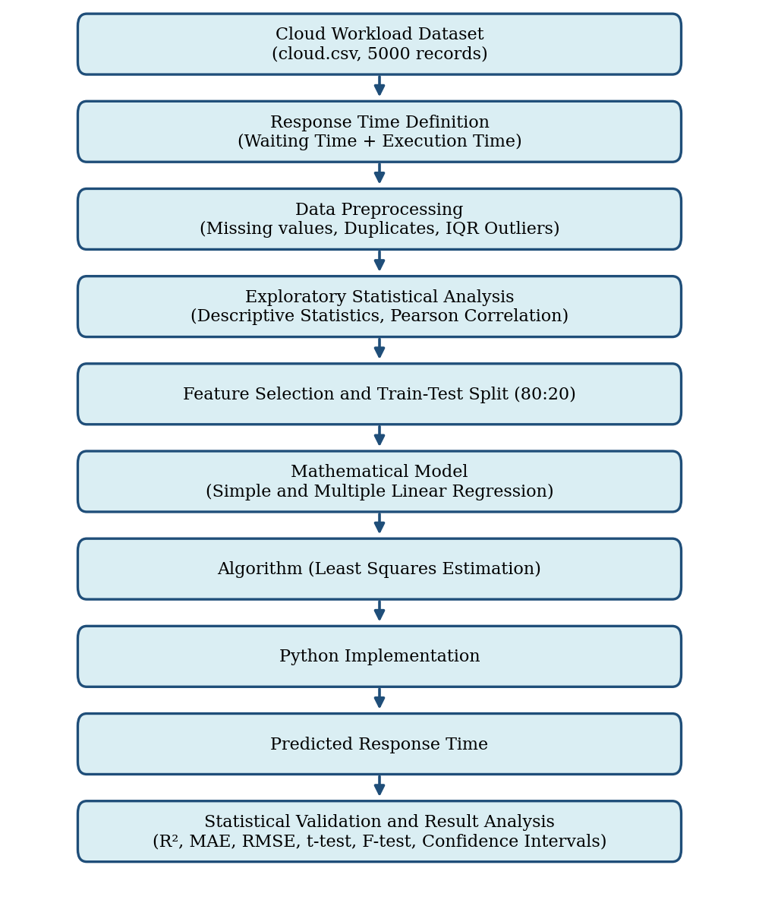
Figure 3.1 Flowchart of the proposed methodology
3.2 Description of the Methodology
Step 1: Input Data. Obtain the Comprehensive Cloud Workload Performance dataset from Kaggle (cloud.csv, 5,000 records, 49 columns) and load it into Python using pandas. The dataset has no ready-made response time column, so response time is defined as the sum of task waiting time and task execution time (in milliseconds), the standard queueing definition. A second dataset of real website measurements (labeled_dataset.csv, 734 records) is used for comparison.
Step 2: Data Preprocessing. Check for missing values and duplicate records. Detect outliers in response time with the interquartile range (IQR) rule, with bounds Q1 − 1.5×IQR and Q3 + 1.5×IQR, and remove records outside them. For the website dataset, remove incomplete rows and invalid zero or negative response times.
Step 3: Exploratory Statistical Analysis. Compute the mean, median, variance, standard deviation and skewness of response time and each parameter, and apply a normality test. Calculate the Pearson correlation between each parameter and response time, and visualise the data with a histogram, scatter plots and a correlation heatmap.
Step 4: Feature Selection and Data Split. Two feature sets are compared. Scenario A uses workload and resource parameters only (CPU utilisation, memory consumption, number of active users, network bandwidth, throughput, error rate, and CPU, memory and bandwidth shares). Scenario B adds the dataset's predicted execution duration. Waiting time and execution time are excluded as features because they make up the response time itself (data leakage). Each dataset is split 80% for training and 20% for testing.
Step 5: Mathematical Model. Response time is expressed as a function of the selected features using simple and multiple linear regression (Section 3.3). A random forest is trained as a non-linear comparison model.
Step 6: Algorithm. The coefficients are estimated by the least squares method, which minimises the sum of squared differences between actual and predicted response times. The procedure is: load data, define response time, preprocess, explore, split, standardise features, fit on the training set, predict on the test set and evaluate.
Step 7: Implementation. The algorithm is implemented in Python using pandas, NumPy, scikit-learn, statsmodels, SciPy, Matplotlib and Seaborn (Chapter 4).
Step 8: Output. Predicted response times are generated for the test set, and the trained model is used to estimate the response time for a new workload condition.
Step 9: Statistical Validation and Analysis. Actual and predicted values are compared using actual-versus-predicted and residual plots. Accuracy is measured with R², MAE and RMSE and checked with 5-fold cross-validation. Significance is judged with a t-test for each coefficient, 95% confidence intervals and an F-test for the whole model at the 5% level. Scenarios A and B are then compared.
3.3 Mathematical Model
Descriptive statistics and correlation
Mean: x̄ = Σx / n Variance: s² = Σ(x − x̄)² / (n − 1) Standard deviation: s = √s²
Outlier bounds: Q1 − 1.5·IQR and Q3 + 1.5·IQR, where IQR = Q3 − Q1
Pearson correlation: r = Σ(x − x̄)(y − ȳ) / √[ Σ(x − x̄)² · Σ(y − ȳ)² ]
Regression model
Simple linear regression: ŷ = β₀ + β₁x, β₁ = Σ(x − x̄)(y − ȳ) / Σ(x − x̄)², β₀ = ȳ − β₁x̄
Multiple linear regression: ŷ = β₀ + β₁x₁ + β₂x₂ + … + βₙxₙ + ε
Least squares: minimise S = Σ(y − ŷ)² ⇒ β = (XᵀX)⁻¹ Xᵀy
Here y is the response time, x₁ … xₙ are the workload parameters, the β values are regression coefficients and ε is the random error term.
Accuracy measures
R² = 1 − SS_res / SS_tot MAE = (1/n) Σ|y − ŷ| RMSE = √[ (1/n) Σ(y − ŷ)² ]
Hypothesis tests and confidence intervals
t-test for each coefficient: H₀: βᵢ = 0 vs H₁: βᵢ ≠ 0, t = β̂ᵢ / SE(β̂ᵢ)
F-test for the whole model: H₀: β₁ = β₂ = … = βₙ = 0
F = (SS_reg / k) / (SS_res / (n − k − 1))
95% confidence interval: β̂ᵢ ± t(0.025, n−k−1) · SE(β̂ᵢ)
A parameter is called statistically significant when its p-value is below the significance level α = 0.05. In this project response time is treated as a continuous random variable whose distribution is described by its histogram, and the regression errors are assumed to be approximately normally distributed, which is checked through the residual plots.
4. FABRICATION/SIMULATION/PROGRAM OR CODE/DESIGN
The project is a software simulation written in Python 3. No hardware fabrication is involved.
4.1 Software environment
• Language: Python 3
• Libraries: pandas and NumPy (data handling), scikit-learn (regression models, train-test split, cross-validation, metrics), statsmodels (OLS summary with t-tests, F-test and confidence intervals), SciPy (skewness and normality test), Matplotlib and Seaborn (plots)
• Datasets: cloud.csv (Kaggle, Comprehensive Cloud Workload Performance) and labeled_dataset.csv (Kaggle, Website Performance dataset)
• Run command: python server_response_time_regression.py
4.2 Program structure
The program is organised into functions that follow the methodology: load_and_preprocess_cloud() performs Steps 1 and 2; explore() performs Step 3 and saves the plots; run_scenario() builds the simple, multiple and random forest models, evaluates them and prints the OLS statistical summary (Steps 4 to 9); predict_new() predicts the response time for a new workload; and website_dataset() repeats the analysis on the second dataset.
4.3 Source code
"""
Server Response Time Prediction Using Regression Models
=======================================================
Micro Project - Probability and Statistics for Data Science and Cyber Security

Datasets (put the CSV files in the same folder as this script, or pass paths):
1. cloud.csv -> Kaggle: Comprehensive Cloud Workload Performance
2. labeled_dataset.csv -> Kaggle: Website Performance dataset (optional)

Run:
pip install pandas numpy scikit-learn matplotlib seaborn statsmodels scipy
python server_response_time_regression.py
python server_response_time_regression.py --cloud path/cloud.csv --web path/labeled_dataset.csv

All plots are saved in the ./outputs folder and all numbers are printed to the console.

IMPORTANT NOTE ABOUT THE CLOUD DATASET
--------------------------------------
cloud.csv has NO column literally called "response time". So we define it the
standard queueing way:
Response Time = Task Waiting Time + Task Execution Time (ms)
"""

import argparse
import os
import warnings

import matplotlib
matplotlib.use("Agg") # saves figures to files; works without a display
import matplotlib.pyplot as plt
import numpy as np
import pandas as pd
import seaborn as sns
import statsmodels.api as sm
from scipy import stats
from sklearn.ensemble import RandomForestRegressor
from sklearn.linear_model import LinearRegression
from sklearn.metrics import mean_absolute_error, mean_squared_error, r2_score
from sklearn.model_selection import cross_val_score, train_test_split
from sklearn.pipeline import make_pipeline
from sklearn.preprocessing import StandardScaler

warnings.filterwarnings("ignore")
OUT = "outputs"
RANDOM_STATE = 42

# Column names in cloud.csv
WAIT = "Task_Waiting_Time (ms)"
EXEC = "Task_Execution_Time (ms)"
PRED_EXEC = "Predicted_Execution_Duration (ms)"
TARGET = "Response_Time_ms"

# Pure workload / resource features (known BEFORE the task finishes)
WORKLOAD_FEATURES = [
"CPU_Utilization (%)",
"Memory_Consumption (MB)",
"Number_of_Active_Users",
"Network_Bandwidth_Utilization (Mbps)",
"System_Throughput (tasks/sec)",
"Error_Rate (%)",
"Memory_Utilization (%)",
"CPU_Share (%)",
"Memory_Share (%)",
"Bandwidth_Share (%)",
]

def header(text):
print("\n" + "=" * 78)
print(text)
print("=" * 78)

def metrics(y_true, y_pred):
return {
"R2": r2_score(y_true, y_pred),
"MAE": mean_absolute_error(y_true, y_pred),
"RMSE": np.sqrt(mean_squared_error(y_true, y_pred)),
}

# ----------------------------------------------------------------------------
# STEP 1-2: LOAD + PREPROCESS
# ----------------------------------------------------------------------------
def load_and_preprocess_cloud(path):
header("STEP 1-2: DATA COLLECTION AND PREPROCESSING (cloud.csv)")
df = pd.read_csv(path)
print(f"Loaded {df.shape[0]} rows x {df.shape[1]} columns")

# Define response time = waiting + execution
df[TARGET] = df[WAIT] + df[EXEC]

print(f"Missing values : {int(df.isna().sum().sum())}")
dups = df.duplicated().sum()
print(f"Duplicate rows : {dups}")
df = df.drop_duplicates()

# Outlier detection using the IQR rule (reported, not blindly removed)
q1, q3 = df[TARGET].quantile([0.25, 0.75])
iqr = q3 - q1
low, high = q1 - 1.5 * iqr, q3 + 1.5 * iqr
n_out = int(((df[TARGET] < low) | (df[TARGET] > high)).sum())
print(f"IQR outliers in response time: {n_out} (bounds {low:.0f} to {high:.0f} ms)")
df = df[(df[TARGET] >= low) & (df[TARGET] <= high)]
print(f"Rows after cleaning: {len(df)}")
return df

# ----------------------------------------------------------------------------
# STEP 3: EXPLORATORY STATISTICAL ANALYSIS
# ----------------------------------------------------------------------------
def explore(df):
header("STEP 3: EXPLORATORY STATISTICAL ANALYSIS")
cols = [TARGET] + WORKLOAD_FEATURES + [PRED_EXEC, WAIT, EXEC]
desc = df[cols].describe().T[["mean", "50%", "std", "min", "max"]]
desc["variance"] = df[cols].var()
print(desc.round(2).to_string())

skew = stats.skew(df[TARGET])
print(f"\nResponse time skewness: {skew:.3f}")
stat, p = stats.normaltest(df[TARGET])
print(f"Normality test (D'Agostino) p-value: {p:.4g} "
f"-> {'approximately normal' if p > 0.05 else 'NOT normal'}")

# Pearson correlation of every feature with response time
corr = df[cols].corr()[TARGET].drop(TARGET).sort_values(ascending=False)
print("\nPearson correlation with Response Time:")
print(corr.round(3).to_string())

# Plot 1: histogram
plt.figure(figsize=(7, 4))
sns.histplot(df[TARGET], bins=40, kde=True, color="#2a6fdb")
plt.title("Distribution of Response Time")
plt.xlabel("Response time (ms)")
plt.tight_layout()
plt.savefig(f"{OUT}/01_response_time_distribution.png", dpi=150)
plt.close()

# Plot 2: correlation heatmap
plt.figure(figsize=(10, 8))
sns.heatmap(df[cols].corr(), cmap="coolwarm", center=0, annot=False)
plt.title("Correlation Heatmap")
plt.tight_layout()
plt.savefig(f"{OUT}/02_correlation_heatmap.png", dpi=150)
plt.close()

# Plot 3: scatter of response time vs key workload features
fig, ax = plt.subplots(1, 3, figsize=(14, 4))
for a, c in zip(ax, ["CPU_Utilization (%)", "Memory_Consumption (MB)",
"Number_of_Active_Users"]):
a.scatter(df[c], df[TARGET], s=5, alpha=0.4)
a.set_xlabel(c)
a.set_ylabel("Response time (ms)")
plt.suptitle("Response Time vs Workload Parameters")
plt.tight_layout()
plt.savefig(f"{OUT}/03_scatter_workload.png", dpi=150)
plt.close()
return corr

# ----------------------------------------------------------------------------
# STEP 4-9: MODEL, TRAIN, EVALUATE, STATISTICAL VALIDATION
# ----------------------------------------------------------------------------
def run_scenario(df, features, name, tag):
header(f"MODELLING - {name}")
print("Features used:")
for f in features:
print(" -", f)

X, y = df[features], df[TARGET]
X_tr, X_te, y_tr, y_te = train_test_split(
X, y, test_size=0.20, random_state=RANDOM_STATE)
print(f"\nTrain size: {len(X_tr)} | Test size: {len(X_te)} (80:20 split)")

results = {}

# Model 1: Simple linear regression on the single most correlated feature
best_single = X_tr.corrwith(y_tr).abs().idxmax()
simple = make_pipeline(StandardScaler(), LinearRegression())
simple.fit(X_tr[[best_single]], y_tr)
results["Simple Linear Regression"] = metrics(
y_te, simple.predict(X_te[[best_single]]))
print(f"\nSimple LR uses the strongest single feature: {best_single}")

# Model 2: Multiple linear regression (main model of the project)
multi = make_pipeline(StandardScaler(), LinearRegression())
multi.fit(X_tr, y_tr)
pred_multi = multi.predict(X_te)
results["Multiple Linear Regression"] = metrics(y_te, pred_multi)

# Model 3: Random forest (non-linear comparison model)
rf = RandomForestRegressor(n_estimators=200, random_state=RANDOM_STATE,
n_jobs=-1)
rf.fit(X_tr, y_tr)
results["Random Forest (comparison)"] = metrics(y_te, rf.predict(X_te))

# Comparison table
table = pd.DataFrame(results).T
cv = cross_val_score(make_pipeline(StandardScaler(), LinearRegression()),
X, y, cv=5, scoring="r2")
print("\nTest-set performance:")
print(table.round(3).to_string())
print(f"\n5-fold cross-validated R2 (multiple LR): "
f"{cv.mean():.3f} +/- {cv.std():.3f}")

# Statistical validation with OLS: t-tests, p-values, 95% CI
ols = sm.OLS(y_tr, sm.add_constant(X_tr)).fit()
print("\nOLS regression summary (training data):")
print(ols.summary().tables[1])
print(f"F-statistic = {ols.fvalue:.2f}, p-value = {ols.f_pvalue:.4g}")
print(f"R2 = {ols.rsquared:.4f}, Adjusted R2 = {ols.rsquared_adj:.4f}")
sig = ols.pvalues.drop("const")
sig = sig[sig < 0.05]
print("Statistically significant features (p < 0.05): "
+ (", ".join(sig.index) if len(sig) else "NONE"))

# Plots
plt.figure(figsize=(5.5, 5.5))
plt.scatter(y_te, pred_multi, s=8, alpha=0.5)
lim = [y.min(), y.max()]
plt.plot(lim, lim, "r--", label="Perfect prediction")
plt.xlabel("Actual response time (ms)")
plt.ylabel("Predicted response time (ms)")
plt.title(f"Actual vs Predicted\n{name}", fontsize=10)
plt.legend()
plt.tight_layout()
plt.savefig(f"{OUT}/{tag}_actual_vs_predicted.png", dpi=150)
plt.close()

resid = y_te - pred_multi
plt.figure(figsize=(6, 4))
plt.scatter(pred_multi, resid, s=8, alpha=0.5)
plt.axhline(0, color="r", linestyle="--")
plt.xlabel("Predicted response time (ms)")
plt.ylabel("Residual (ms)")
plt.title(f"Residual Plot\n{name}", fontsize=10)
plt.tight_layout()
plt.savefig(f"{OUT}/{tag}_residuals.png", dpi=150)
plt.close()

return multi, table

def predict_new(model, features, values, label):
"""Predict the response time for a new workload condition."""
row = pd.DataFrame([values], columns=features)
print(f"[{label}] predicted response time = {model.predict(row)[0]:.1f} ms")

# ----------------------------------------------------------------------------
# OPTIONAL: SECOND DATASET (real website measurements)
# ----------------------------------------------------------------------------
def website_dataset(path):
header("SECOND DATASET: labeled_dataset.csv (real website measurements)")
d = pd.read_csv(path).dropna()
d = d[d["Response Time(s)"] > 0] # removes invalid negative/zero readings
print(f"Rows after cleaning: {len(d)}")

feats = ["Page Size (KB)", "Load Time(s)", "Throughput"]
target = "Response Time(s)"
print("\nPearson correlation with response time:")
print(d[feats + [target]].corr()[target].drop(target).round(3).to_string())

# Response time is heavily right-skewed, so we also try a log transform
X = d[feats]
for label, y in [("raw response time", d[target]),
("log(response time)", np.log(d[target]))]:
X_tr, X_te, y_tr, y_te = train_test_split(
X, y, test_size=0.2, random_state=RANDOM_STATE)
m = make_pipeline(StandardScaler(), LinearRegression()).fit(X_tr, y_tr)
r2 = r2_score(y_te, m.predict(X_te))
print(f"Multiple LR on {label}: test R2 = {r2:.3f}")

# ----------------------------------------------------------------------------
# MAIN
# ----------------------------------------------------------------------------
def main():
ap = argparse.ArgumentParser()
ap.add_argument("--cloud", default="cloud.csv")
ap.add_argument("--web", default="labeled_dataset.csv")
args = ap.parse_args()
os.makedirs(OUT, exist_ok=True)

df = load_and_preprocess_cloud(args.cloud)
explore(df)

# Scenario A: pure workload parameters only (the project's original idea)
model_a, table_a = run_scenario(
df, WORKLOAD_FEATURES, "Scenario A: workload parameters only", "A")

# Scenario B: add the dataset's own predicted execution duration
feats_b = WORKLOAD_FEATURES + [PRED_EXEC]
model_b, table_b = run_scenario(
df, feats_b, "Scenario B: workload + predicted execution duration", "B")

header("PREDICTING FOR A NEW WORKLOAD (example)")
sample = df[feats_b].median().to_dict()
sample["CPU_Utilization (%)"] = 90
sample["Number_of_Active_Users"] = 4500
predict_new(model_a, WORKLOAD_FEATURES,
[sample[f] for f in WORKLOAD_FEATURES], "Scenario A")
predict_new(model_b, feats_b, [sample[f] for f in feats_b], "Scenario B")

if os.path.exists(args.web):
website_dataset(args.web)
else:
print(f"\n(Skipping second dataset: {args.web} not found)")

header("FINAL COMPARISON (test R2 of Multiple Linear Regression)")
print(f"Scenario A (workload only) : "
f"{table_a.loc['Multiple Linear Regression', 'R2']:.3f}")
print(f"Scenario B (+ predicted duration) : "
f"{table_b.loc['Multiple Linear Regression', 'R2']:.3f}")
print(f"\nPlots saved in the '{OUT}' folder.")

if __name__ == "__main__":
main()
5. RESULTS AND INTERPRETATION
5.1 Dataset and preprocessing
The cloud dataset contained 5,000 records and 49 columns. There were no missing values and no duplicate rows. Response time (waiting time + execution time) ranged from 135 ms to 5,984 ms. The IQR rule gave bounds of −1,946 ms and 7,975 ms and flagged no outliers, so all 5,000 records were used. One data-quality issue was noted: the predicted execution duration column contains a few negative values (minimum −173 ms).
5.2 Descriptive statistics
Table 5.1 Descriptive statistics of response time and selected parameters (n = 5,000)
Variable | Mean | Median | Std. dev. | Min | Max
Response time (ms) | 3016.97 | 2976.00 | 1447.53 | 135 | 5984
CPU utilisation (%) | 49.75 | 50.00 | 23.17 | 10.00 | 89.98
Memory consumption (MB) | 4218.14 | 4235.50 | 2142.39 | 502 | 7998
Active users | 2565.99 | 2614.00 | 1431.85 | 50 | 4998
Network bandwidth (Mbps) | 499.52 | 501.60 | 283.97 | 10.07 | 999.73
Throughput (tasks/sec) | 5.27 | 5.29 | 2.71 | 0.50 | 10.00
Error rate (%) | 2.52 | 2.52 | 1.45 | 0.00 | 5.00
Predicted execution duration (ms) | 2511.03 | 2488.00 | 1427.22 | −173 | 5261

The response time distribution is almost symmetric (skewness 0.055) with its mean (3,017 ms) close to its median (2,976 ms). The D'Agostino normality test rejected normality (p < 0.001) because the distribution is flat rather than bell-shaped, as Figure 5.1 shows.
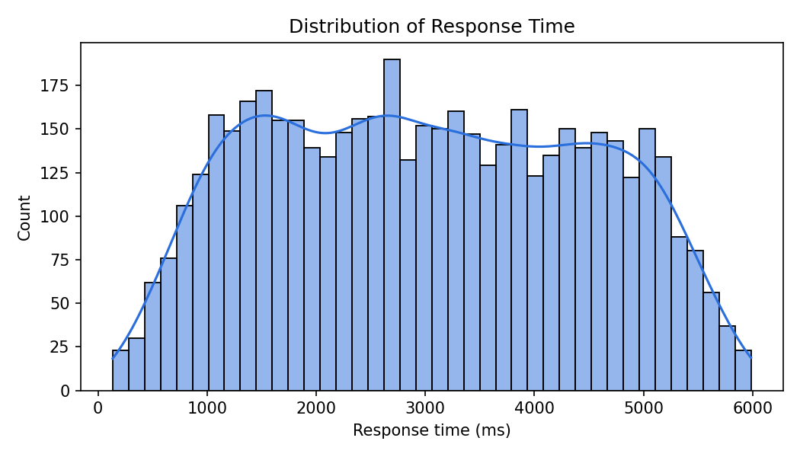
Figure 5.1 Distribution of response time
5.3 Correlation analysis
Table 5.2 Pearson correlation of each parameter with response time
Parameter | r | Parameter | r
Task execution time (ms) | 0.980 | CPU utilisation (%) | 0.007
Predicted execution duration (ms) | 0.973 | Network bandwidth (Mbps) | −0.001
Task waiting time (ms) | 0.211 | System throughput | −0.001
Bandwidth share (%) | 0.041 | CPU share (%) | −0.004
Memory consumption (MB) | 0.026 | Error rate (%) | −0.008
Memory utilisation (%) | 0.022 | Number of active users | −0.011
Memory share (%) | 0.016

Execution time and waiting time have high or moderate correlation with response time simply because they are its two components (they were excluded as features). Among the genuine workload and resource parameters, every correlation is below 0.05 in absolute value. CPU utilisation, memory consumption and the number of active users have essentially no linear relationship with response time in this dataset. The predicted execution duration is the only independent parameter strongly related to response time (r = 0.973).
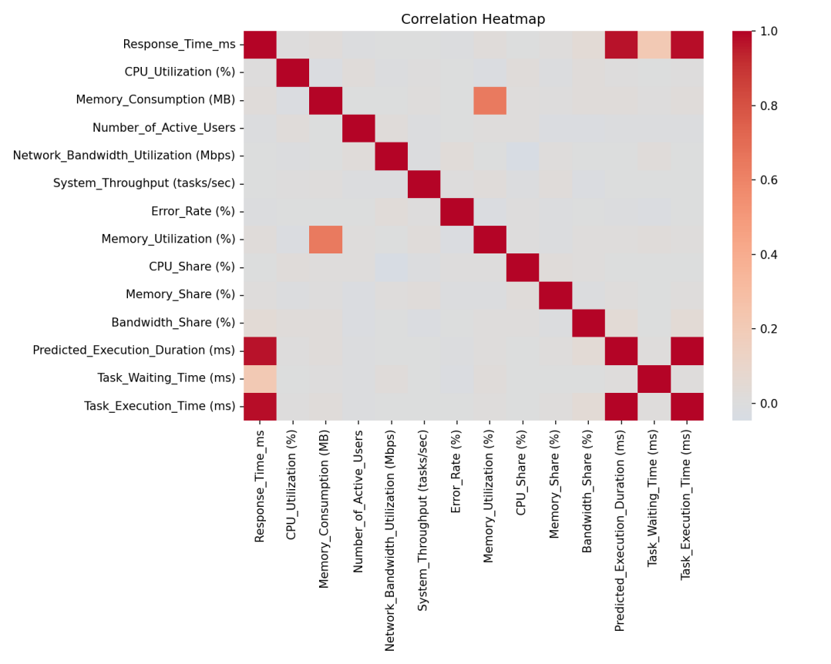
Figure 5.2 Correlation heatmap
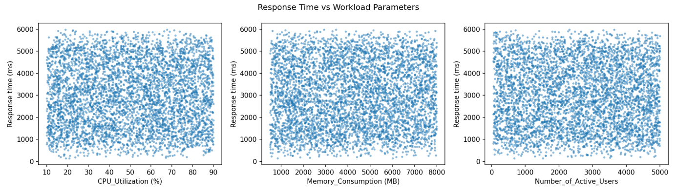
Figure 5.3 Response time against CPU utilisation, memory consumption and active users
5.4 Model performance
Table 5.3 Test-set performance (80:20 split)
Scenario | Model | R² | MAE (ms) | RMSE (ms)
A: workload only | Simple linear regression | 0.002 | 1249.9 | 1454.1
A: workload only | Multiple linear regression | 0.002 | 1248.4 | 1453.9
A: workload only | Random forest | −0.037 | 1271.3 | 1481.9
B: + predicted duration | Simple linear regression | 0.945 | 286.2 | 342.6
B: + predicted duration | Multiple linear regression | 0.944 | 287.5 | 344.6
B: + predicted duration | Random forest | 0.942 | 290.1 | 351.5

The 5-fold cross-validated R² of multiple linear regression was −0.002 ± 0.004 for Scenario A and 0.946 ± 0.003 for Scenario B, which agrees with the test-set results and shows that they are not an accident of one particular split.
Scenario A: workload and resource parameters only
The model explains almost none of the variation in response time (R² = 0.002). Its mean absolute error (about 1,248 ms) is close to what one would get by always predicting the average, and the random forest, a more flexible model, does no better (R² below zero). Figure 5.4 shows predictions that stay near the mean regardless of the actual value.
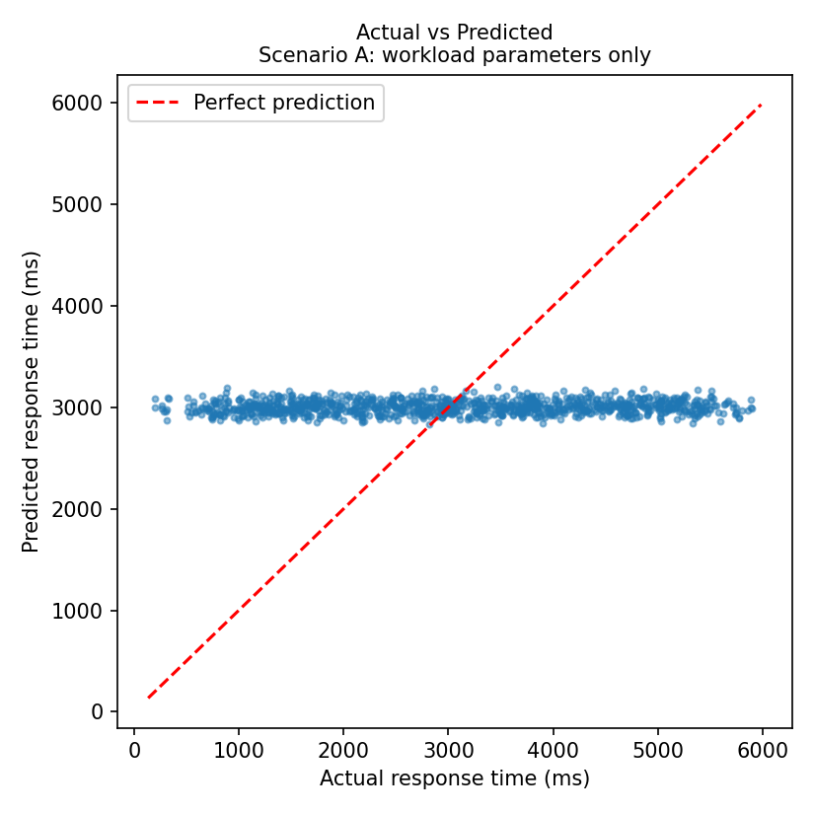
Figure 5.4 Actual versus predicted response time, Scenario A
Scenario B: with predicted execution duration
Adding the predicted execution duration raises R² to 0.944 and cuts the mean absolute error to about 287 ms. The points in Figure 5.5 lie close to the line of perfect prediction, and the residuals in Figure 5.6 are scattered randomly around zero without a clear pattern. A simple regression on this one feature performs as well as the multiple regression, and the random forest gives no improvement, so the relationship is essentially linear.
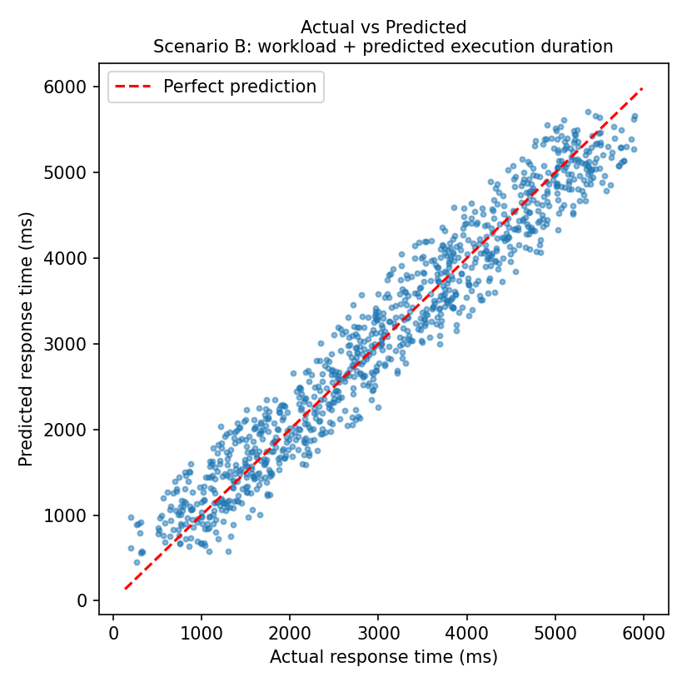
Figure 5.5 Actual versus predicted response time, Scenario B
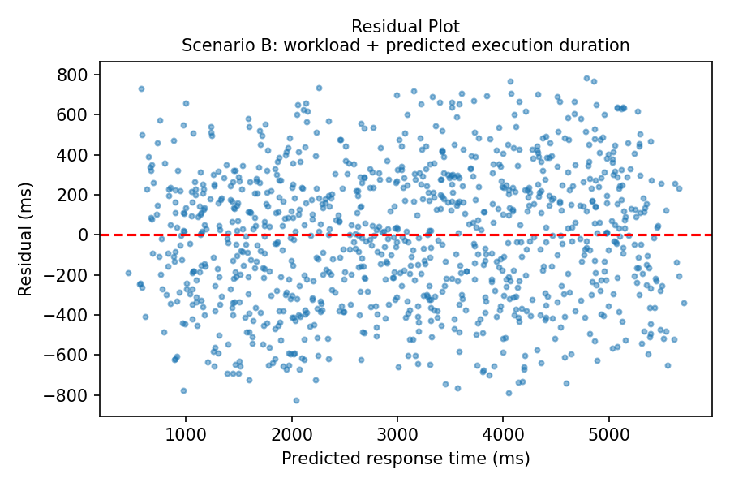
Figure 5.6 Residual plot, Scenario B
5.5 Hypothesis tests and confidence intervals
Ordinary least squares fitted on the training data gave the following statistical tests. The null hypothesis for each coefficient is H₀: β = 0 (the parameter has no effect), tested at the 5% level.
Table 5.4 F-test for the overall model
Scenario | F-statistic | p-value | R² | Adjusted R² | Decision
A: workload only | 0.86 | 0.5675 | 0.0022 | −0.0003 | Fail to reject H₀
B: + predicted duration | 6466.44 | < 0.001 | 0.9469 | 0.9468 | Reject H₀

Table 5.5 Coefficient tests, Scenario B (selected rows)
Parameter | Coefficient | Std. error | t | p-value | 95% CI
Constant | 570.87 | 32.60 | 17.51 | < 0.001 | 506.96 to 634.78
Predicted execution duration | 0.9826 | 0.0037 | 266.40 | < 0.001 | 0.975 to 0.990
CPU utilisation | −0.1607 | 0.228 | −0.71 | 0.480 | −0.607 to 0.286
Memory consumption | 0.0022 | 0.003 | 0.67 | 0.502 | −0.004 to 0.009
Active users | −0.0053 | 0.004 | −1.43 | 0.154 | −0.013 to 0.002

In Scenario A the F-test (p = 0.5675) does not reject the null hypothesis, so the ten workload and resource parameters taken together have no statistically significant effect on response time. Only bandwidth share had an individual p-value below 0.05 (coefficient 1.83, p = 0.041, 95% CI 0.08 to 3.59), but with ten separate tests at the 5% level one such result is expected by chance, and the model as a whole explains just 0.2% of the variance, so this should not be treated as a real effect.
In Scenario B the F-test strongly rejects the null hypothesis. The predicted execution duration is the only significant parameter: each additional millisecond of predicted duration adds about 0.98 ms to the response time (95% CI 0.975 to 0.990). The fitted model is approximately: Response time ≈ 570.9 + 0.983 × Predicted execution duration. All the other parameters remain insignificant (p between 0.14 and 0.83).
5.6 Prediction for a new workload
For a new workload with CPU utilisation of 90% and 4,500 active users (other parameters at their median values), the Scenario A model predicts a response time of 2,993.9 ms and the Scenario B model predicts 2,978.8 ms. Because the Scenario A model has no real predictive power, its value is essentially the dataset average, and it does not respond to the heavier load.
5.7 Second dataset: real website measurements
After removing incomplete rows and invalid zero or negative values, 732 website records remained. Page size, load time and throughput had correlations of −0.033, 0.028 and −0.148 with response time. A multiple linear regression gave a test R² of 0.006 on raw response time and 0.061 after a log transformation, which was applied because response time is strongly right-skewed. These parameters therefore also explain very little of the response time of real websites.
5.8 Interpretation
Workload parameters alone did not predict response time. In the cloud dataset the CPU, memory, user, bandwidth and throughput columns appear to have been generated independently of the timing columns (their correlations are near zero and their values are spread almost uniformly), so no regression model can recover a relationship that is not in the data. This is a property of the dataset, not a coding error, and the random forest result confirms it.
A high R² must be read with care. The Scenario B result is accurate, but the predicted execution duration is itself an estimate of most of the response time (r = 0.973). Scenario B shows that the regression and testing pipeline works correctly when real signal exists; it is not evidence that CPU or memory load drive response time.
Statistical tests protect against false conclusions. Without the F-test and cross-validation, an isolated significant coefficient in Scenario A could have been mistaken for a finding. The tests show that the evidence is too weak.
Limitations. The data is synthetic or limited in scope, response time was defined from two columns, only linear relationships were mainly tested, and only a single train-test split plus cross-validation was used.
6. CONCLUSION AND FUTURE SCOPE
6.1 Conclusion
This micro project applied probability and statistics to the problem of predicting server response time. Descriptive statistics, correlation analysis, simple and multiple linear regression, error measures, cross-validation, t-tests, an F-test and confidence intervals were all applied to a 5,000-record cloud workload dataset in Python.
The main findings are: (1) using workload and resource parameters alone (CPU, memory, active users, bandwidth and related columns), regression could not predict response time (R² = 0.002, F-test p = 0.57); (2) adding the predicted execution duration gave an accurate model (R² = 0.944, MAE about 287 ms), with that duration the only significant predictor; and (3) a second dataset of real websites also showed weak relationships (R² = 0.006). The project therefore shows both how a regression-based predictor is built and tested, and why statistical validation is needed before trusting a prediction model.
6.2 Future scope
• Collect real measurements by load-testing a web application with tools such as Apache JMeter or Locust while recording CPU and memory with psutil, so that the workload parameters genuinely drive the response time.
• Fit probability distributions (normal, exponential) to response time and compute the probability of breaching an SLA threshold, for example P(response time > 4000 ms), with a chi-square goodness-of-fit test.
• Compare more models, such as polynomial, ridge, Gaussian process and gradient boosting regression, and time-series models such as ARIMA for forecasting.
• Use the prediction error as an anomaly score to detect DDoS attacks or failing servers in real time.
• Integrate the trained model into a live monitoring dashboard for automatic capacity planning and alerting.

DECLARATION

I understand that Karunya Institute of Technology and Sciences retains the rights to any product developed (software or hardware) through the Micro Project submitted by me to the Institution.
Furthermore, if I intend to document or publish any findings from the Micro Project work for commercial purposes, I shall obtain a No Objection Certificate (NOC) from the Office of the Registrar before engaging in such activities.
I also understand that any patentable outcomes arising from the Micro Project shall be reported to the Institution, and that patent filing, ownership, and revenue-sharing will be governed by the Intellectual Property Rights (IPR) policies of Karunya Institute of Technology and Sciences.
I acknowledge that any commercial utilization or republication of the Micro Project work, in full or in part, shall require prior permission from Karunya Institute of Technology and Sciences. I further agree that any royalty accruing from such utilization will be shared between the inventor(s) and the Institution in the ratio of 60:40, respectively, in accordance with the Institute’s Intellectual Property Rights policy.

Signature of the Students: | 
Name of the Students: | Dharani Dharan M  Lithish Kumar P  Danush A T  Rowan Matthew R
Register Number: | URK25AI1043  URK25AI1027  URK25AI1013  URK25AI1012
Date: | 27.10.2026

